Running and Installing OSAMS

1. Install python 3
   1. This can be found here <https://www.python.org/downloads/release/python-385/>
      1. Windows users can enter python3 into PowerShell and they will sometimes be redirected to an install
   2. Alternatively, Anaconda can be installed, this comes with most modules pre-installed. Python needs to be run in the Conda environment to access the modules.
2. Open python environment
   1. This is normally done by entering python3, if this does not work, try py3 or python. Python is running if there is >>> on the current line

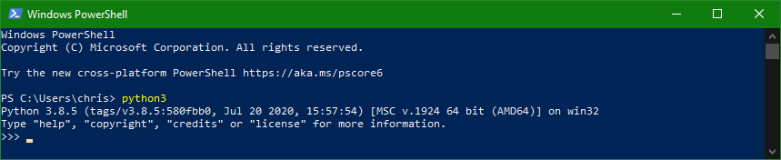

* 1. For Conda see here <https://docs.anaconda.com/anaconda/navigator/getting-started/>, normally this is done by opening Anaconda Prompt. This is successful if there is >>> on the current line.

1. Install packages
   1. Required packages numpy, scipy, pandas, matplotlib, xlrd
   2. Using pip: pip install {somepackage}

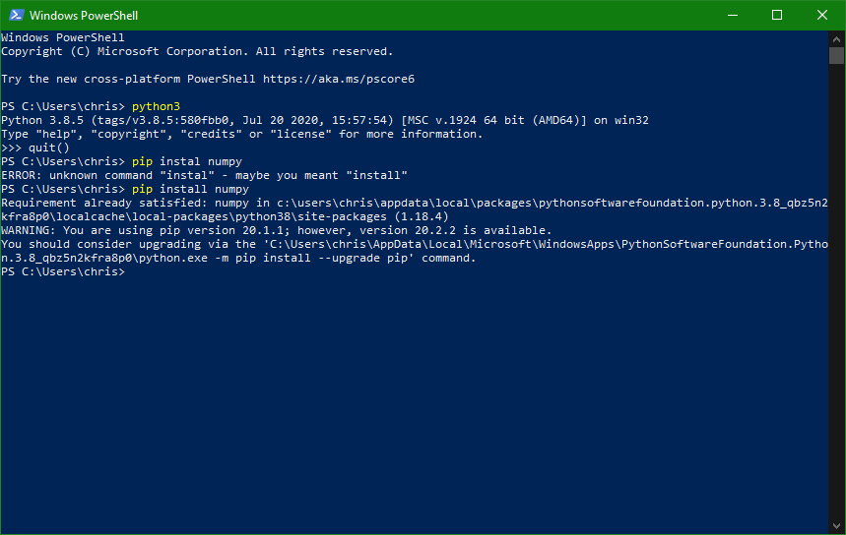

* 1. Anaconda should already have all modules installed, if not see <https://docs.anaconda.com/anaconda/user-guide/tasks/install-packages/>

1. Download OSAMS
2. In the directory where OSANS_RUN.py is located move the mesh templates, g-code file, and inp file like so

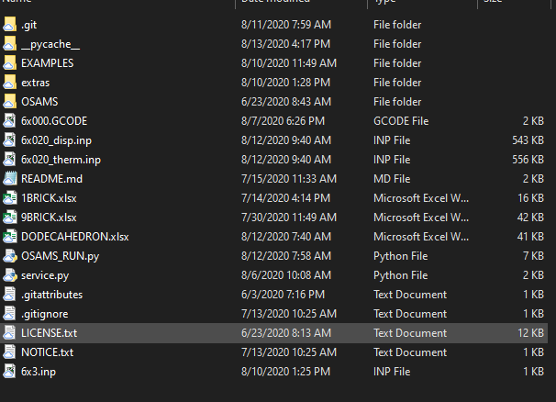

1. Open OSAMS_RUN.py in your python environment
   1. Normally this is done using the following commands on windows

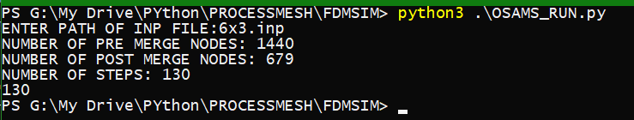

* 1. For Anaconda users, run OSAMS_RUN in the Conda environment

This can also be done within an IDE like Spyder by opening OSAMS_RUN pressing the run button. You will then be prompted to enter the location of the .inp file in the I Python console

